
Virtual Consultation
Patient Guide

What is a virtual consultation?
Virtual consultations are available to patients as a way for you to connect directly with your healthcare team via video or telephone from the comfort of your home using your smartphone, tablet or computer.

As with in-person consultations, virtual consultations are conducted as private conversations between you and your clinician to discuss topics related to your medication.

Preparing for a successful virtual consultation.
Virtual consultations may seem intimidating. As with most things, preparation is key. Here are a few tips to help ensure you make the most out of your appointment:

You will need:
A webcam-enabled computer, smartphone or tablet with good-quality speakers, a microphone and a web browser
An internet (wi-fi) or a phone data plan (for connections via mobile device) A stable internet connection
A quiet indoor space with little distraction and good lighting

Take a moment to jot down any questions that you want to discuss with your clinician. It’s a good idea to write down a few notes in advance to make the best use of your time during your virtual consultation.
Have a pen and paper handy in case you want to take notes from your consultation.

Consider having someone join you, either in-person or virtually. Depending on the type of consultation, it may be helpful to have a family member, trusted friend or caregiver sit in to take notes or raise concerns in case you forget something. If the individual can’t be in the same location as you, share their contact details with your clinician so they can be sent a link to join the call

Joining your virtual consultation.

15 minutes ahead of your scheduled appointment time, click on the Virtual Consultation link that your hospital shared with you via SMS (text message) or email.
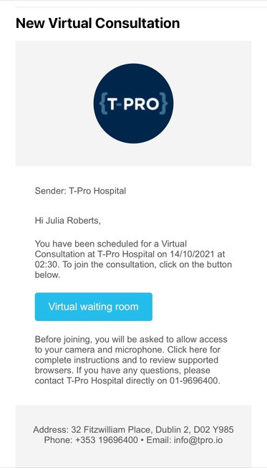

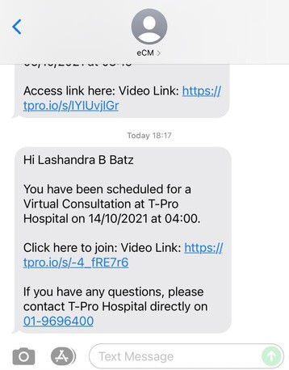
Note: If this is your first virtual consultation with your hospital, we recommend that you test your device connection. To do so, ensure that you are using a smartphone, tablet or computer with both camera and microphone access.

Your device must have one of the following operating systems and subsequent browsers for the virtual consultation to be launched:

Mac OS X 10.12 and later - latest version of Chrome, Firefox or Safari
Windows 7 or Windows 10 - latest version of Chrome, Firefox or Microsoft Edge iOS 11 and later - latest version of Safari
Android 9 and later - latest version of Chrome Chrome OS - latest version of Chrome

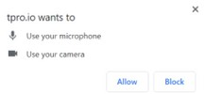
You may be asked to allow access to your camera and microphone. If you are prompted to do so, please click “allow” for both.




Ensure your camera and microphone are working correctly. You should see yourself on screen in the virtual consultation waiting room. At the specified consultation time, your clinician will join. It may take a moment or two to connect.

Hello!
Welcome to T-Pro Hospital's Virtual Consultation Waiting Room.
We will be with you shortly. Thank you for your patience

Note: You must have both video and audio access to connect. If you cannot connect, please contact your hospital.



Once your clinician joins, they will appear on the screen with you. If needed, there is a chat feature that can be used during your video session.
When your virtual consultation is complete the clinician will close the connection. At this time, you may close your internet browser to disconnect from the video call.



Contact us

For general enquiries, please contact our main switchboard by calling 02920 747747

Visit our website

https://cavuhb.nhs.wales/

